


Frogston Primary School

School Travel Plan 2026

School Context
Frogston Primary School is a new school established in Edinburgh in August 2020, with the new building opening in August 2021. The school is situated within the new housing development to the south of Frogston Road East with an outstanding new building and extensive, beautifully landscaped grounds. We use our environment, both indoors and out, to promote excitement, innovation, creativity and independence in all teaching and learning opportunities. The school has seen rapid growth over the past few years growing from just 28 Primary 1 pupils in August 2020 to 18 classes with a roll of 460 pupils in August 2026. This new extension was completed in July 2026. It has 6 new classrooms and a couple of office spaces situated within the new wing.
Our building can accommodate 21 classes with a roll of up to 610 pupils.
We have 110 children enrolled in Early Years. We have 3 models of delivery with 48 term time places, 20 am/pm places and 12 Monday/Tuesday or Wednesday/Thursday places including 20 eligible 2s places.
The school employs around 70 staff across the school and Early Years Centre.
The school has a school-run Breakfast Club for primary school children that runs from 7.45am – 8.45am daily with provision for about 100 children. There is an after-school club run by Daddy Daycare with provision for up to 100 children running from 2.50pm – 6.15pm Mondays – Thursdays and from 12.10pm – 6.15pm Fridays.

School Catchment
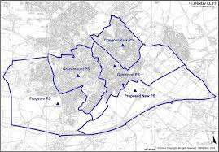

School Travel Audit
Cycling facilities: | The school has 6 visitor cycle parking spaces at the main entrance, 16 open spaces and 40 covered spaces within the grounds. There are currently no dedicated cycling facilities in the adjacent streets which are in a low-speed residential area. However, cycling is permitted on the paths which run through the green spaces and new ones are planned along Frogston Road East and Burdiehouse Road with construction planned for this financial year.  https://consultationhub.edinburgh.gov.uk/sfc/walkwheelcycle-burdiehouse/results/ldpaplot3conceptdesignpackagefinal.pdf
Traffic  speeds: | The entire residential estate surrounding the school has a 20-mph speed limit. Two major roads, Frogston Road East and Burdiehouse Road have a 30-mph speed limit.
Pedestrian crossings: | The residential estate has several uncontrolled crossings whilst there are signalised crossings at Kaimes crossroads and the junction of Greenwell Wynd and Burdiehouse Road.
Footway and accessibility, road  markings: | The school is accessible by several dedicated footways and paths running through  the estate. All accesses from Frogston Road East, Achnacarry Street and Bowbridge Crescent have School Keep Clear markings. Beyond the school, the new residential development has yet to be adopted and currently lack road markings.
School Street scheme: | A School Street Scheme is proposed for this school. This scheme will include;  Achnacarry Street, Bowbridge Crescent and Hepburn Crecsent. A TRO is currently prepared by the TRO-team. This scheme will not be in place before the summer of 2027.
Public transport: | Janefield bus stop on Burdiehouse Route is served by the 37, 47 and 47B  services. Kaimes Crossroads on Frogston Road East has the 11 and 18 services.  Howdenhall Road stop is served by the 7, 27, 47, 47B and X62
Safety patrol crossing guards: | There are no crossing guides dedicated to this school.
Hands-up survey:
  Year | Walk | Cycle | Scooter  / Skate | Park & Stride | Driven | Bus | Taxi | Other
  2022 | 45.6% | 6.0% | 12.6% | 10.7% | 22.8% | * | * | 0.0%
  2023 | - | - | - | - | - | - | - | -
  2024 | 41.0% | 6.4% | 6.4% | 13.6% | 29.0% | 3.6% | 0.0% | 0.0%
  2025 | 39.0% | 15.0% | 7.0% | 10.0% | 26.0% | 2.0% | 1.0% | 0.0%
School  survey outcomes: | The main concerns and reasons for improvements are due to congestion of traffic dropping off and collecting children from school.
Disabled persons parking  provision | There are 2 disabled parking spaces within the school car park.

What are we hoping to achieve?
The main goal will be to get everyone safely to and from school. This can be done by reducing risks, more Active Travel, more eco-friendly etc.

Action Plan
Based and combined with the proposed actions from the Audit document.
Action: | Action holder: | Timeline:
Pupils from P6 selected to be Junior Road Safety Officers. Pupils to attend induction on Friday 4th September 2026. | School Team | September 2026
JRSOs to lead the school in promoting Active Travel to school. | JRSOs and staff lead. | On-going session 26-27.
Implement School  Street Scheme | Road Safety Team | Short/ Medium/  Long term
Communication about School  Street Scheme | Road Safety Team | Short (when progressed by TRO  team)
Alignment of  pedestrian crossings | Developer, RCC Team | Short
Access controlled  car park | Road Safety Team  and school | Short



How to get to Frogston Primary School
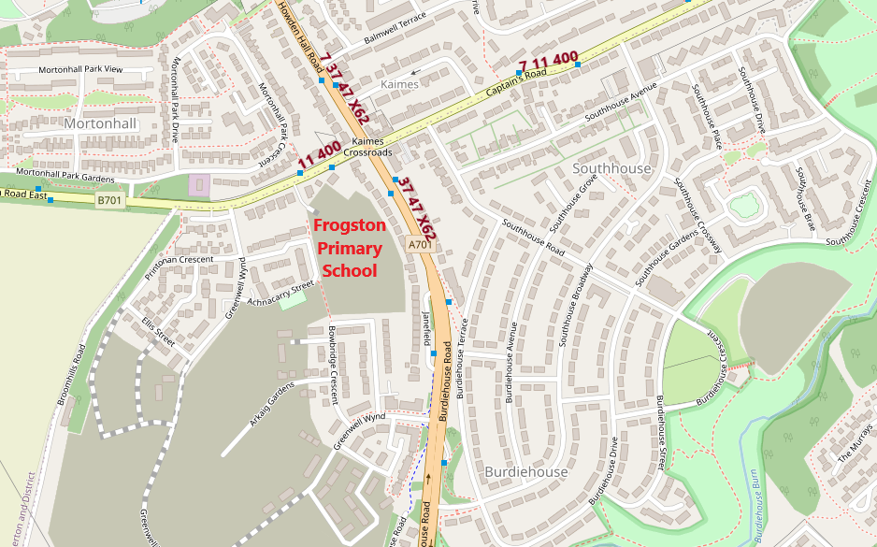
This map from Open Street Map shows the location of:
Paths in red, Cycle routes in purple, Bus Stops in blue and Bus routes in maroon.
Walking:
To find a walking route or cycle route try https://www.edinburgh.gov.uk/cycling-walking/explore-quietroutes
Cycling:
Frogston Primary School links directly onto quiet streets connected by paths. These connect through to the new housing on the opposite side of Straiton Road
To plan a point-to-point bike journey go to www.cyclestreets.net also available as an App for IOS and Android.
There are a wide variety of free maps available detailing off-road and quiet routes to the school and around the area. www.edinburgh.gov.uk/cycling-walking contains a set of eight maps covering North, North West, North East, South, South West, South East, West Edinburgh and Rosslyn Chapel Way as well as suggestions of interesting places to go and a further Guidance leaflet with information on road safety, cycle training and choosing and maintaining a bicycle. The new school will be on the South sheet.
Public Transport:
The nearest bus stops are on Frogston Road East - 2 minutes walk from the school.
These are served by:
11 – Hyvots Bank to Ocean Terminal via Captain’s Road, Frogston Road, Comiston Road, Morningside Road, Lothian Road, Princes Street, George Street, Newhaven Road and Lindsey Road every 10 minutes.
400 – Fort Kinniard to Edinburgh Airport via Niddrie, Greendykes, Royal Infirmary, Gilmerton, Gracemount, Fairmilehead, Oxgangs, Firrhill, Colinton, Wester Hailes, Sighthill, The Gyle, RBS Gogarburn and Ingliston Park and Ride every 30 minutes.
From Howden Hall Road – 4 minutes walk from the school.
7 – Royal Infirmary to Newhaven via Old Dalkeith Road, Ferniehill Road, Gracemount, Liberton Gardens Cameron Toll, Newington Road, The Bridges, Leith Walk, Great Junction Street, Ferry Road and Newhaven Road every 15 minutes.
37 – Penicuik (Deanburn) or Easter Bush to Silverknowes via Roslin, Loanhead, Straiton Retail Park, Liberton Gardens, Cameron Toll, Newington, The Bridges, Princes Street, Queensferry Street, Westerm General, Crewe Toll and Pennywell Gardens every 15 minutes.
47 – Penicuik (Ladywood) to Granton Harbour via Easter Bush (47B), IKEA, Straiton Park & Ride, Liberton Gardens, Cameron Toll, Newington, Lauriston Place, Lothian Road, Queensferry Street, Western General, Crewe Road North and Waterfront Avenue every 30 minutes.
Borders X62 - Edinburgh to Galashiels via Straiton, Penicuik, Leadburn, Eddleston, Peebles, Innerleithen, Walkerburn and Clovenfords every 30 minutes.
Full timetables are on www.lothianbuses.com or ring 0131 555 6363
For X62 see www.bordersbuses.co.uk or ring 01896 754350
For real time bus info see www.mybustracker.co.uk
To plan a point-to-point journey, click on www.travelinescotland.com or ring 0870 6082608.
Mobile apps are available for all the above.
Park and Stride:
Local businesses who have agreed that parents can use their car parks when dropping off or collecting children from Frogston Primary School:
Toby Carvery
Mortonhall Garden Centre (overflow carpark)
Gracemount Leisure Centre
Valley Park Community Centre (the car park opposite, next to ValU)

Monitoring
- Annual updates will be done on the actions, STP will be renewed every 5 years.

How can you help?
These are examples for parents/ caretakers to keep the area around the school safe.
- Comply with road safety rules
- Set a good example when travelling
- Communicate openly and well with your child(ren) and other parents
- Be bright, be seen
- Volunteer and get involved
- Check the council website for more relevant information

